# SQL CLASS - 4

# TOPICS – TCL, DQL/DRL Commands

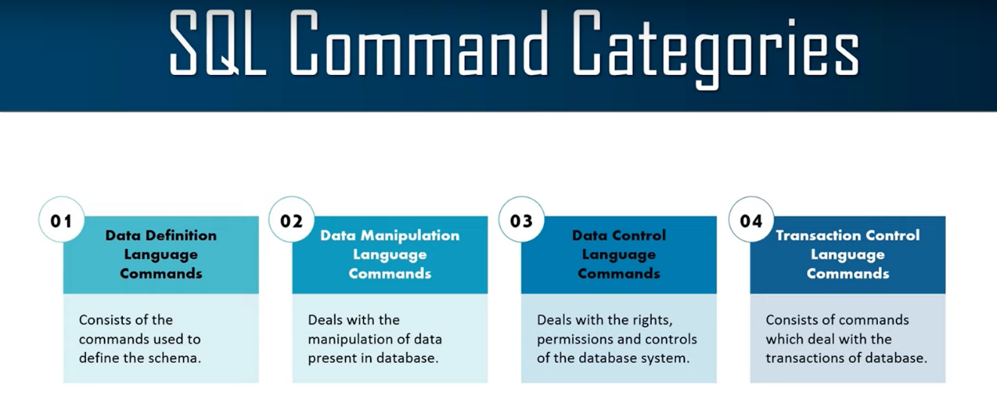

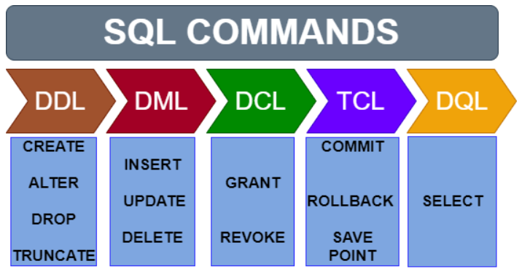

1. Transactional Control Language (TCL) - **Commit, Rollback, Savepoint**

**What is a Transaction?**

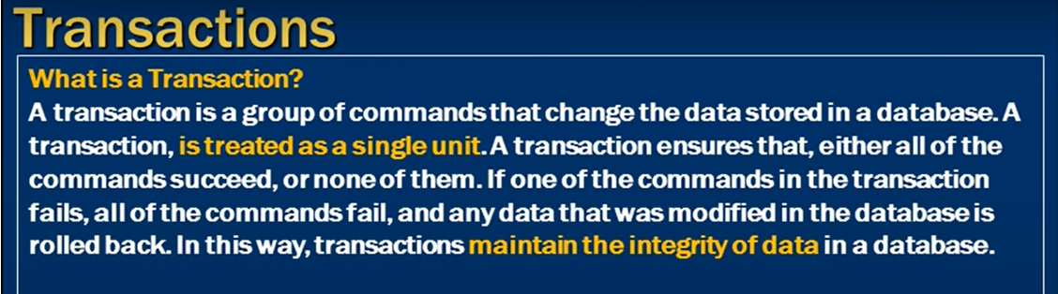

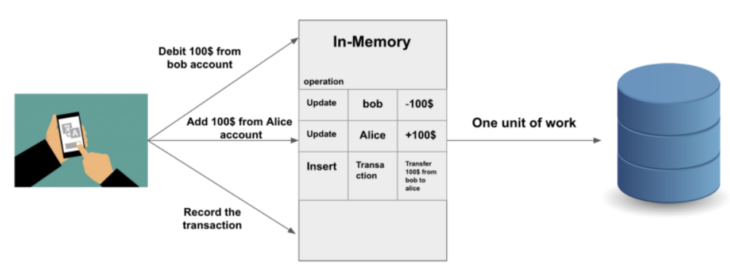

1. **Commit -** To make changes permeant in database

* Commit is used to make changes permanent. When we use Commit in any query then the change made by that query will be permanent.
* We used to perform commit after DML operations
* We cannot Rollback after the Commit.

**Syntax -** Commit**;**

**Example -**

DELETE FROM studentsInfo WHERE StudentId = 2;

Commit**;**

1. **Rollback -**

* Rollback is used to undo the changes made by any DML command but only before a commit is done.
* We can't Rollback data that has been committed in the database with the help of the commit keyword.

**Syntax -** Rollback**;**

**Example -**

DELETE FROM studentsInfo WHERE StudentId = 2;

Rollback**;**

1. **Savepoint -**

* It is used to temporarily save a transaction so that you can rollback to that point whenever required.
* If there are 2 savepoints S1 and S2 and user rollback to savepoint S1 then S2 savepoint will be automatically deleted.

**Syntax -** ROLLBACK TO Savepoint_name;

**Example -**

DELETE FROM studentsInfo WHERE StudentId = 2;

DELETE FROM studentsInfo WHERE StudentId = 3;

SAVEPOINT S1;

DELETE FROM studentsInfo WHERE StudentId = 4;

SAVEPOINT S2;

DELETE FROM studentsInfo WHERE StudentId = 5;

ROLLBACK TO S2;

ROLLBACK TO S1;

(**Note**- After rollback to S1 you cannot use savepoint S2)

1. Data Retrieval /Query Language (DRL/DQL) - **Select**
2. **Select -** used to retrieve data from a table.

* It is used to Fetch or Retrieve or Display or Read data from the table.
* It is used to retrieve the information from the database objects for read only purpose.

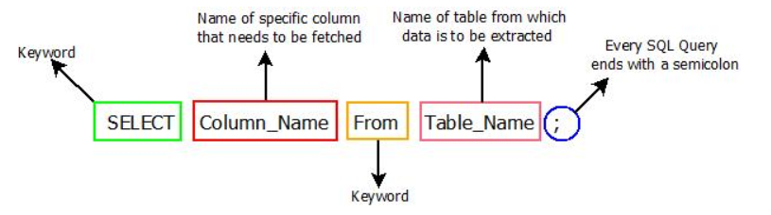

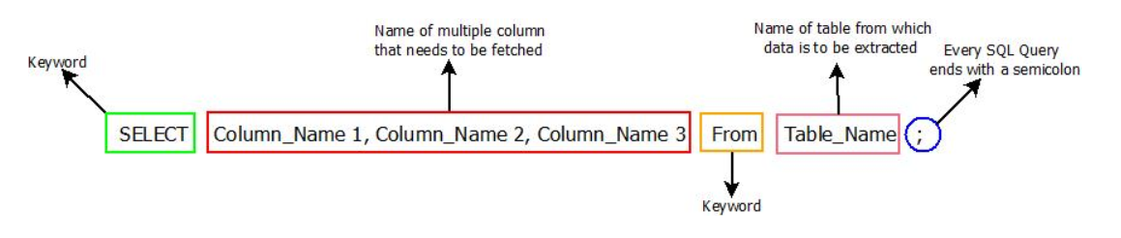

**Syntax -** SELECT * / list of columns FROM table_name WHERE condition;

**Example -**

SELECT * FROM studentsInfo;

SELECT StudentName, PhoneNumber, City FROM studentsInfo;

SELECT PhoneNumber, City, StudentName FROM studentsInfo;

SELECT * FROM studentsInfo WHERE StudentId = 1;

SELECT StudentName, PhoneNumber, city FROM studentsInfo WHERE StudentId = 1;

**Perform arithmetic calculation or to print string using select** -

**Example** -

SELECT 10 +12 FROM dual;

SELECT 10 +12/3 * 9 FROM dual;

SELECT (10 +17)/3 * 9;

SELECT ((100 + 100) - (50 + 50)) FROM dual;

SELECT 'Welcome to SQL Class' FROM dual;

__________________________THANK YOU____________________________